Extending Network:
Port forwarding is an essential component in connecting applications and services to the Internet.
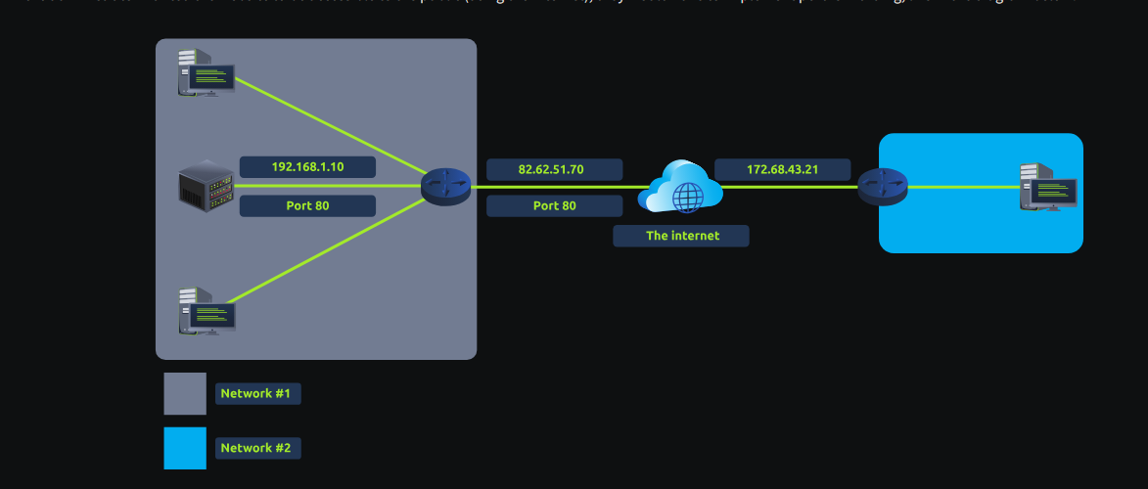

Firewall:
A firewall is a device within a network responsible for determining what traffic is allowed to enter and exit.
Think of a firewall as border security for a network.
- Where the traffic is coming from? (has the firewall been told to accept/deny traffic from a specific network?)
- Where is the traffic going to? (has the firewall been told to accept/deny traffic destined for a specific network?)
- What port is the traffic for? (has the firewall been told to accept/deny traffic destined for port 80 only?)
- What protocol is the traffic using? (has the firewall been told to accept/deny traffic that is UDP, TCP or both?)

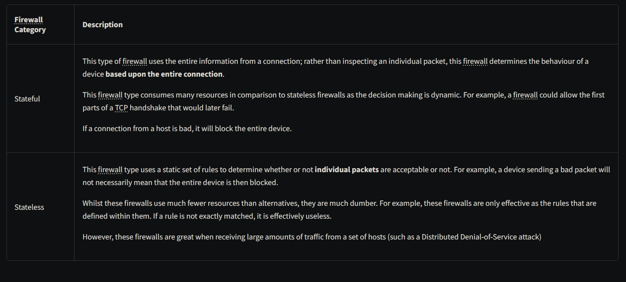
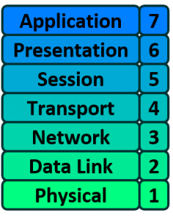
VPN Basics:
A Virtual Private Network (or VPN for short) is a technology that allows devices on separate networks to communicate securely by creating a dedicated path between each other over the Internet
